**Resolution Independent Vertical Horizontal Layout in Unity UI**

**Unity UI中独立垂直与独立横向布局的解决方案**

Objective

目标

Main objective of this blog post is to give you an idea about How to work with Independent Vertical Layout and Independent Horizontal Layout in Unity UI.

这篇博文主要目标是给你一个建议告诉你如何在Unity UI中做独立垂直布局和独立横向布局。

Vertical Layout:

垂直布局：

The Vertical Layout Group component places its child layout elements on top of each other. Their heights are determined by their respective minimum, preferred and flexible heights according to the following model:

垂直布局组的组件放置在每个子节点分布元素的顶部。他们的高度决定他们各自的最小值，优选和灵活高度依照下面的模式：

* The minimum heights of all the child layout elements are added together and the spacing between them is also added. The result is the minimum height of the Vertical Layout Group.
* 所有子节点布局元素的最小高度是加起来的，并且她们之间空间也是加起来的。运算结果就是垂直布局组的最小高度。
* The preferred heights of all the child layout elements are added together as well as the spacing between them is added. As a result you will get the preferred height of the Vertical Layout Group.
* 当他们之间的空间增加时所有子节点布局元素的优选高度也会叠加。结果你就会得到这个垂直布局组的优选高度。
* If the Vertical Layout Group is at its minimum height or smaller, all the child layout elements will also have their minimum height.
* 如果垂直布局组是在最小或更小高度，所有子节点布局元素也将会有他们的最小高度。
* The closer the Vertical Layout group is to its preferred height, the closer each child layout will get to their preferred heights.
* 垂直布局组与优选高度越近，每个子节点将与他们的优选高度越近。
* If the Vertical Layout Group is taller than its preferred height, it will distribute the extra available space proportionally to the child layout elements according to their respective flexible heights.

Here I have taken a resolution independent example using vertical layout.

如果垂直分布组比优选高度更高，它会根据他们各自的灵活的高度按比例分配另外有效的空间给子节点布局元素。

这里我已经用垂直分布组举了一个独立决议的例子。

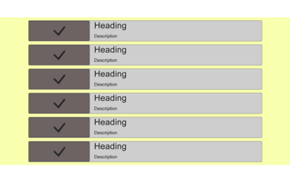

Step 1 Create Panel

第一步，创建面板

Create panel from Create **⇒** UI **⇒** Panel and name it Panel - Vertical Layout.

创建面板点击Create=>UI=>Panel 并且命名它为Panel - VerticalLayout

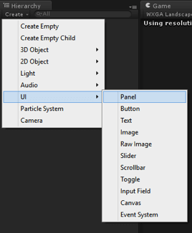

Step 2 Create one more Panel

第二步，创建更多面板

Under the Vertical Layout Panel and name it to Panel - Item Container

放在垂直布局面板下面并命名为Panel - Item Container

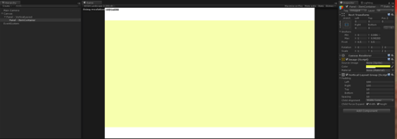

Step 3 Create Panel item under the Panel

第三步，在面板下创建面板节点项

Item Container and add some buttons and text in the panel.

加节点容器并加一些按钮和文本在面板上。

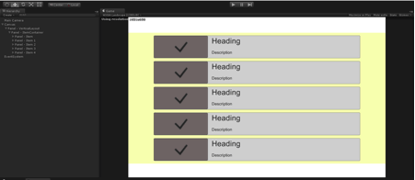

Step 4 Duplicate the Panel Items

第四步，复制面板节点项

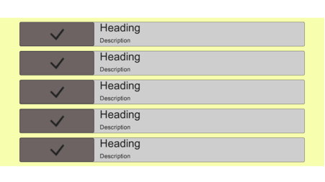

Step 5 Check the Output

第五步，检查结果

Check the output by changing the screen resolutions. Like Bellow is 600 * 1024 resolution output, you can check it in all the resolutions. It will always give the best fit output in every resolution.

检查在更换屏幕分辨率后的结果。比如下面600*1024分辨率结果，你可以在所有的分辨率下进行检查。在每个分辨率下它将总是会有最好的适配结果。

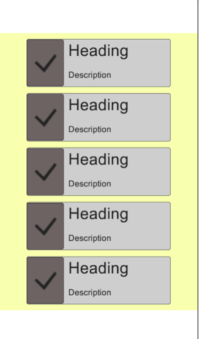

I hope you find this blog very helpful while working with Independent Vertical Layout or Independent Horizontal Layout in Unity UI 4.6. Let me know in comments if you have any question regarding Unity UI.

我希望当你在Unity UI 4.6中做独立垂直布局或独立横向布局时会发现这篇博文对你非常有帮助。如果你有任何有关于Unity UI的问题请在评论里留言。

[**Free Download Full Source Code!!!**](http://github.com/tejas123/resolution-independent-vertical-horizontal-layout-in-unity-ui-4-6/archive/master.zip)

**免费的完整源码！！！**